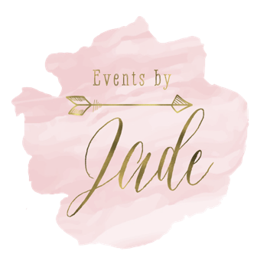

Ceremony
_______ & ______

Prelude Music:

Honored Guest- Grandmother
______, escorted by _____, and seated on (which side) ____.

Honored Guest- Grandmother
_____, escorted by _____, and seated on _____.
_____ follows

Honored Guest- Grandmother
_____, escorted by ____, and seated on _____.

Honored Guest- Grandmother
_____, escorted by _____, and seated on _____.

Groom’s Mother
_____ , escorted by _____. _____ follows

Bride’s Mother
_____, escorted by _____.

Wedding Party Entrance Song- “ ________”

Pastor and Groom enter together

Groomsmen – Best man should enter last

- ________________
- ________________
- ________________
- ________________
- ________________
- ________________
- ________________
- ________________
- ________________
Bridesmaids: (MOH should enter last)

- ________________
- ________________
- ________________
- ________________
- ________________
- ________________
- ________________
- ________________
- ________________

Ring Bearer:

_____

Flower Girls:

_____

Entrance of the Bride-
BRIDE enters holding dad’s left arm.

Ceremony…

Unity Ceremony

Recessional Song-

____ & _____
____ & _____
____ & _____
____ & _____
____ & _____
____ & _____
____ & _____
____ & _____

Grandparents/parents escorted out?

NOTES:

